Kenya ICT CFT Course
Accessibility Guide

Introduction
The KICTCFT course (http://kictcft.nba.co.za) is designed to aid teachers acquire skills and competencies to allow them to incorporate ICT in their teaching and student learning. The course is run predominately online and uses web based technologies to allow participants access communication tools, digital materials and the course activities. In order to ensure success a teacher needs to be comfortable working in this virtual learning environment (VLE).

Beside dedicated access to a digital device and robust ubiquitous connectivity the participant needs to be comfortable working in the Moodle course management platform. This is especially so if the participant has physical challenges, such as impaired hearing or sight. Consequently this guide is designed to support the KICTCFT participant customise their computer to optimise their course experience.

Ideal Computer Setup for the KICTCFT course
There are many different ways the KICTCFT course can be accessed. For example it is possible to use the Moodle Mobile App to improve access to the course via a smart phone and small or mini tablets. However, should the user have any physical challenges it is advised that the following set to be used to optimise accessibility to the course.

Physical Device
- Use a laptop computer (with keyboard) rather than a touch screen device such as a tablet.
- Laptop should have a video cam;
- Laptop should have a microphone;
- Have a large screen in excess of 15”;
- Have a mouse (pointing device) installed rather than use the trackpad.

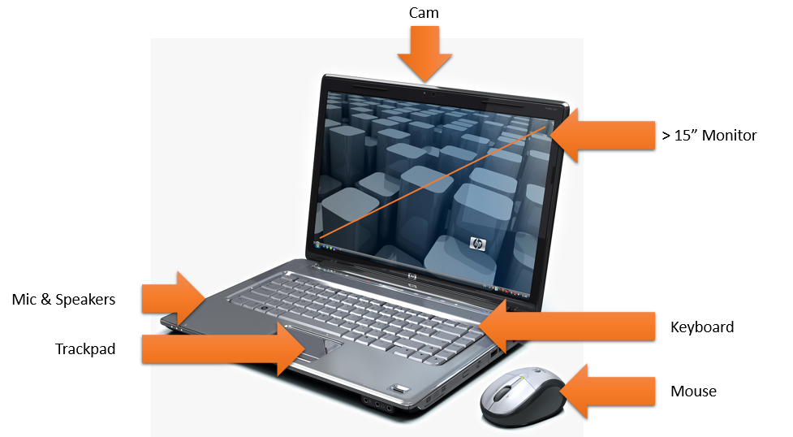

Operating System & Application Software
The following OS and application software is advised;
- Use Windows 10 operating system that has numerous accessibility options in the Settings window including;
  - Narrator - A Text to Speech (TTS) facility that reads text that appears on the screen whenever you move the cursor or pointer close to a line of text. You can choose different voices and use one that is understandable.
  - Improve Contrast - Choose different screen themes each designed to increase contrast of the Windows environment to improve visibility
  - Magnifier – A toggle that allows the screen to be magnified. Has a range from 100% to 400%.
  - Mouse - Toggle that allows the mouse cursor to be magnified and/or leave a trail as it moves across the screen designed to identify where on the screen the mouse cursor is.
To access these settings click | Settings | Ease of use.

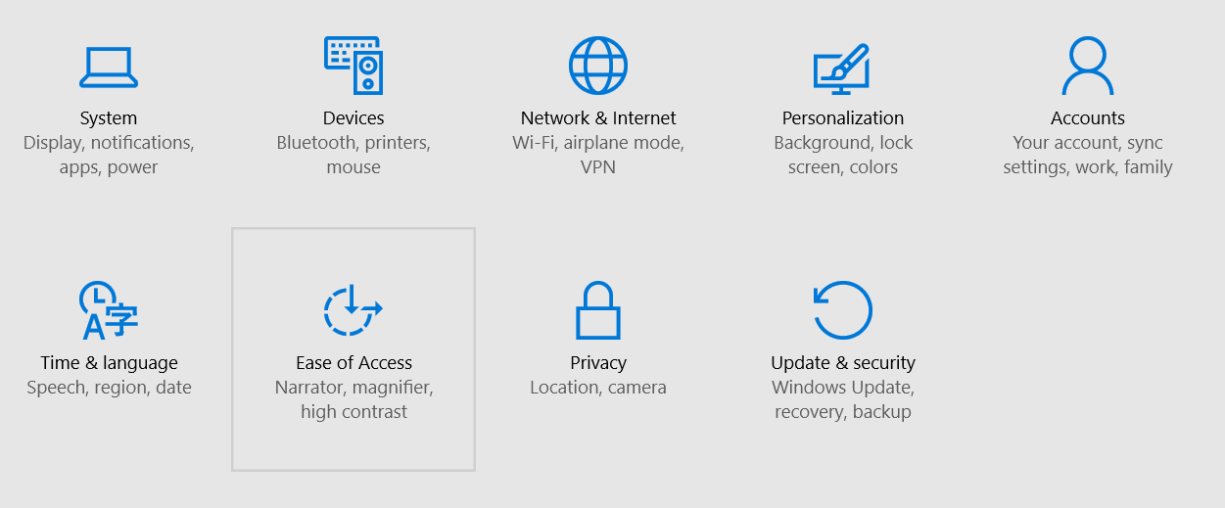

- The free Google Chrome internet browser
- Microsoft’s Office suite of programs (MS Word, MS Excel, MS PowerPoint)
- A free PDF reader to access documents
- The free Flash player to allow YouTube videos to play

Customising your Browser
The Moodle system that contains the KICTCFT course is completely web based and is accessed using a web browser. We recommend Google’s Chrome Browser which you can access and download at (https://www.google.com/chrome/browser/desktop/). We recommend this browser because the course was built and tested using it and in addition there are a number of accessibility options available which will help access.

Browser Settings
Customise any of these settings to enhance accessibility;

Font size
The browser allows you to zoom in or out by enlarging the screen size.
- Click on the icon and from the drop down box either increase (+) or decrease (-) the zoom.

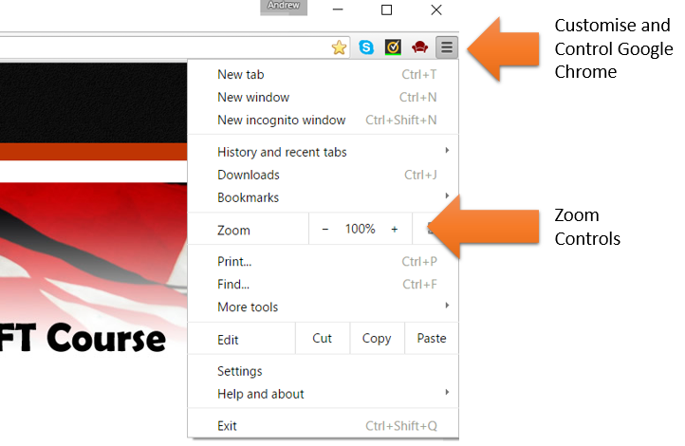

Apps & Extensions
Install accessibility extensions that add additional functionality to the browser. Some suggested free extensions available at https://chrome.google.com/webstore/category/ext/22-accessibility and include:
- ChromeVox – a TTS extension, similar to that in Windows ‘Ease of Use’ settings, but designed to better understand the layout of webpages.
- ChromeVis – Allows the user to customise the text colour and backgrounds of any web-page to improve its readability for coloured blind or low sight users. There is also an magnification tool.
- ChromeShades – is an app aimed at blind users. It forces a particular style on any web page viewed to enhance it so that it can appreciated by blind users.
- Readability – an extension that allows you to download the main text of webpage and present it in an uncluttered format. Adverts and distracting blocks are removed. The extension also allows you to select font, fontsize and the number of lines on a ‘page’ to enhance readability.
- VoiceNote II – A Speech to text extension that allows the user to speak into the laptop’s microphone and the browser software converts the signal to text. The text can then be copied and pasted into any Moodle rich text editor window.

Google’s Accessibility Manuals
Google has produced accessibility guides for all their software so should you also use Google docs, drive, gmail etc. then accessibility support for these applications can be accessed at; https://support.google.com/a/answer/1631886#h3_chrome

Assistive Technology Products
Should you be in need of more sophisticated support and are willing, and/or able to invest in proprietary solutions the following is a list of recommended software:

Speech to Text – Text to Speech Software
Software that can read aloud screen text and then write on your behalf based on what you dictate

- Dragon Naturally Speaking http://www.nuance.com/dragon/accessibility-solutions/index.htm

Braille Embossers
A braille embosser is an impact printer that renders text as tactile braille cells. Using braille translation software, a document can be embossed with relative ease, making braille production efficient and cost-effective.
- Enabling technologies http://www.brailler.com/

Keyboard filters
Typing aids such as word prediction utilities and add-on spelling checkers that reduce the required number of keystrokes. Keyboard filters enable users to quickly access the letters they need and to avoid inadvertently selecting keys they don't want.

Light signaler
Lights triggered by computer sounds that alert the computer user. This is useful when a computer user cannot hear computer sounds or is not directly in front of the computer screen. As an example, a light can flash alerting the user to the arrival of new email.

